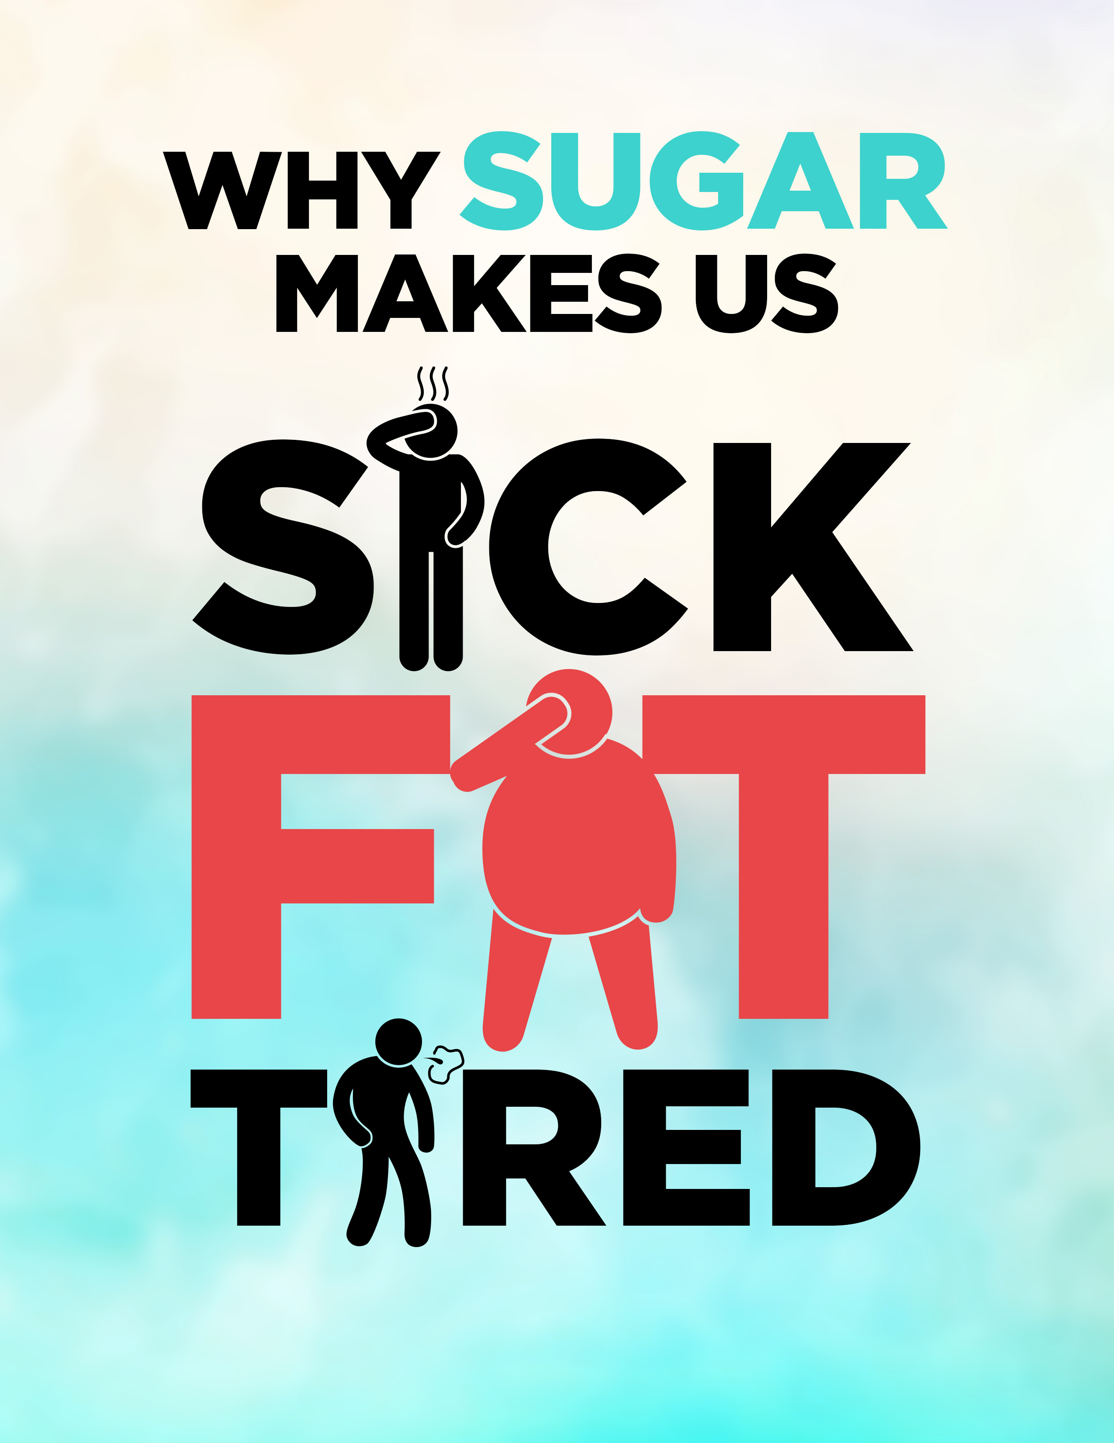

Why Sugar Makes Us Sick, Fat, and Tired

I overheard two older gentlemen talking at a local attraction park as they watched families goes by.
One said to the other, “Back in my day, in the 40’s through 60’s, everyone was slim. Now everyone is fat. Everyone says they’re always tired. It seems like everyone is sick.”
He had a point. As I gazed across the stream of people, I realized many people were obese. Some over overweight. Few were slim.
A startling number of children were overweight.
This is consistent with the numbers you’ll find online about obesity and weight in America.
The new slim of today is carrying a few extra pounds.
It doesn’t make sense that so many people struggle with weight problems. No one wants to be overweight.
So why don’t they just stop eating so much?
You might have just thought, “I did stop eating so much! It’s not working!”
I’m here to tell you today that eating too much isn’t the real problem.
Overeating does cause weight gain, but the issue in America today is that we don’t know what we’re eating in our food.
We’re ingesting a toxin that creates a vicious weight-gain cycle.
This toxin is making us sick and tired all of the time, and making it almost impossible to lose weight.
If you’re dieting and exercising and wondering why you can’t lose weight, why you’re sick and exhausted, you might be surprised to learn it’s the type of sugar in most of the food we eat.

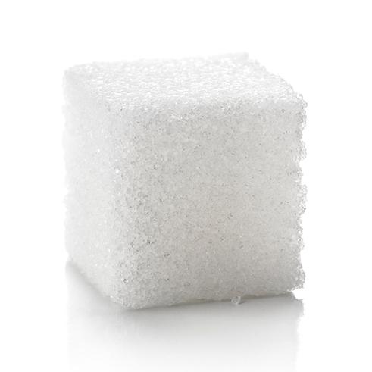
Sugar....
Sugar consumption in general is a problem. We’re not made to process so much sugar.
It’s causing inflammation that leads to disease, throwing off hormones and making us tired, and leaving us craving more.
Excess sugar leads to heart disease, the number one killer in America.
Most Americans are aware of this problem, and yet so few actually change their diet to a low sugar diet.
We’re seeing an epidemic of diabetes, heart disease, cancer, autoimmune diseases related to inflammation, and many other modern day health issues.
We know this is diet related. Why aren’t we doing more?
High fructose corn syrup is a huge problem. Even if that were cut and we used sugar in products again, we would be eating too much.
The problem is that sugar and corn syrup in everything, and very hard to avoid.
Even when we do change our diet and buy “healthy” foods, we don’t feel better.
Let’s say this is what you eat in day:
- Yogurt for breakfast
- A mocha on the way to work
- Two granola bars before lunch
- A sandwich for lunch along with sweet tea from a bottle
- An afternoon latte (you think it’s healthier than a mocha)
- A small pack of fruit cocktail
- Steak, potatoes, and broccoli for dinner with wine
I’ll admit that this doesn’t sound that unhealthy to me. Some of it sounds actually good for your health.
Let’s go through it more closely.
A plain yogurt with fresh fruit would be healthy, although dairy also causes problems for our health.
The store bought yogurt with the fruit in it has a mind-blowing amount of sugar. It feels like a healthy treat, but it has sugar and/or high fructose corn syrup.

The mocha... Well, we’ll talk about coffee drinks in a bit. The flavorings are full of corn syrup.
You’re also getting high fat dairy, or possibly soy milk which causes hormones problems similar to a thyroid issue.
The granola bars are health food, right? Probably not. Very few are low sugar. Most are held together with corn syrup.
The bread in the sandwich has high fructose corn syrup, and so does the dressing.
That sweet tea? It might have sugar, which would be better, but bottled sweet tea usually has corn syrup instead.
The latte also has corn syrup.
That fruit cocktail is packed in corn syrup too. It’ll give you a spurt of energy followed by a crash.
Your dinner is healthier, but the potatoes might have some ingredients you’re not aware of, if they came from a mix.
A glass of red wine can be healthy.
I like white wine, and that’s full of sugar too. It might not be that bad, except that your diet all day had sugar and high fructose corn syrup.
This day’s menu is pretty typical for many American women. We think we have some health foods in there, but really we’re eating sugar all day long.

That’s why we wake up already tired, sometimes not feeling well, and wondering what on earth is going on with our body.
Here is the startling truth...
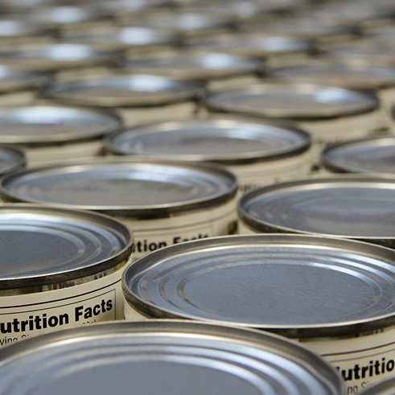
Do you remember the Batman movie where the Joker poisoned random products?
People had no way of knowing if they were exposed and how much poison they had consumed or put on through makeup.
People would suddenly start laughing and die with a big Joker smile stuck on their face.
Commercially produced food in America is basically the same situation.
We have an ingredient in almost all foods, and it’s one that we can’t really process.
It’s a type of sugar that’s even worse for us, as I’ll soon explain.

How did this sugar problem start?
In the 1970s, the government realized America had a heart disease problem.
After some studies, they decided that Americans ate too much fat, and so the war on fat began.
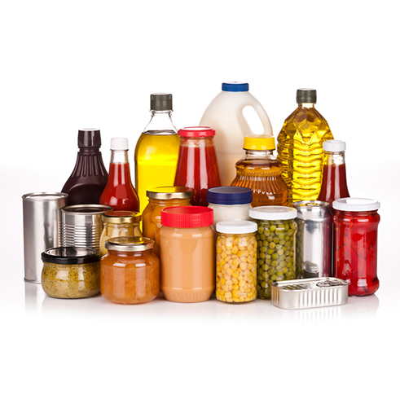
The science behind it had found that with more fat in the diet, people had more heart problems.
These studies noted an increase in sugar, too, but it apparently made more sense to blame the fat.
The public was told to cut fat.
Food companies introduced low-fat products. They took the fat out, which made food taste bad, so they replaced the fat with different forms of sugar.
Japan discovered a way to make sugar out of corn: high fructose corn syrup. It’s sweeter than sugar and MUCH cheaper to produce.
It’s smooth, so it makes products soft, creamy, and sweet.
Turns out, it works well in sauces, breads, and almost ALL packaged foods.
So America went from eating moderate amounts of cane sugar, aka glucose, to eating more and more fructose.
A lot of sugar, or any food for that matter, is not good for your health.
If you eat salt in everything, you’ll encounter different problems. The same is true if you eat all meat, or all vegetables without any protein.
Moderation is key.
But since 1970, Americans have eaten more and more fructose until it’s at an alarming rate.
Some people are eating around 150 pounds of sugar a year, and around 60 pounds of that is fructose. They don’t know what they’re eating.
You might be worried because you drink soda and eat treats. You know you need to cut back.
Or, you might be thinking that you don’t eat much because you buy healthy food. Do you buy crackers? Weight loss snacks?
How about baby formula for your infant? Did you know that’s half sugar?
Formula is 43% corn syrup solids and 10% sugar.
Formula is 50% sugar! It’s over 40% fructose!
Remember that fact for after our discussion of what fructose does to our body.

What is Fructose? And what does it do to our body?
We used to consume more glucose, or plain sugar. That’s the white crystals that you add to your coffee and use to bake with at home.
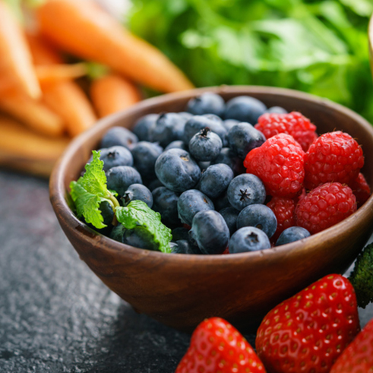
Fructose is the sugar that comes out of fruit. That doesn’t sound too bad. It’s natural.
If you eat an apple, some berries, and other fruit in one day, it’s not that bad for your health.
You’re getting a lot of fiber from the fruit, and that keeps your body from absorbing all of the natural sugar.
The fiber is a essential nutrient that provide many health benefits. The U.S. government doesn’t classify it as essential, because it’s been stripped out of processed food.
The problem with fructose happens when you pull it out of the fruit and eat it by itself.
Juice is an example.
Studies prove that juice causes weight gain, diabetes, and other weight and sugar related health problems.

The WIC program has been providing low-income families with free juice for a few decades now.
We’ve seen a huge increase of obesity in small children, like two and three year olds.
Fructose by itself is a toxin. The fiber is an antidote. I’ll show why soon.
Let’s look at the difference between glucose and fructose in our body.
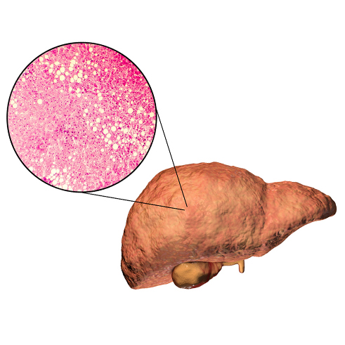
When we consume glucose, 80% of the calories are used by our organs.
Every cell in the human body—and living organism—can use glucose for energy.
20% of the calories go to the liver where a natural process breaks the sugar down.
At the end of this process, a signal tells the brain to shut off your hunger feeling so you stop eating.
That’s what happens with plain old sugar.
With fructose, ONLY the liver can metabolize it, not the rest of the body.
This is the definition of a poison.

The way the liver breaks fructose down is really unique, and that’s what makes it so bad for us.
Fructose doesn’t trigger an insulin response.
So it has to be broken down a different way, and that method creates uric acid. This acid causes gout and hypertension.
Fructose is 7 times more likely to form AGE’s in our body; that stands for Advanced Glycation End-Products. That’s what we see when a steak browns in a pan.
Further, fructose doesn’t suppress the hunger hormone ghrelin so it doesn’t turn our hunger off.
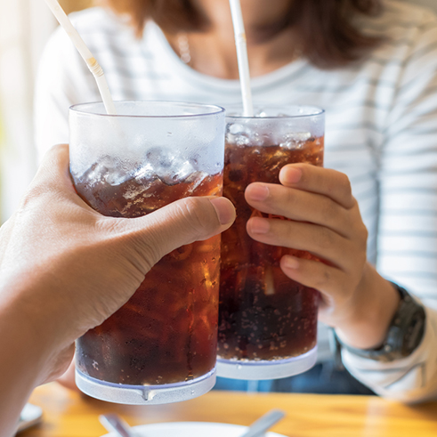
Due to this, we’ll drink of soda with 150 calories and then eat more than we normally would.
Fructose also doesn’t stimulate insulin or leptin, so no signal goes to the brain telling it that we ate something. Our body gets calories that the brain doesn’t register.
Studies show that fructose increases “de novo lipogenesis” (new fat creation) in normal adults.
That’s what we’re seeing in children who regularly drink juice too.
30% of fructose calories become fat. Less than 5% of glucose calories do.
A high sugar diet (of fructose) is actually a high fat diet because you end up with more fat in your body.
Fructose causes fatty liver and liver insulin resistance.
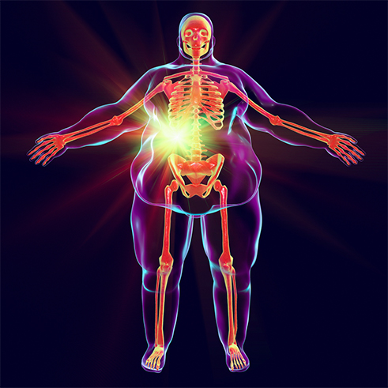
Sadly, the way fructose is broken down doesn’t let the brain know that you’re getting calories. The brain thinks you’re starving.
So fructose causes obesity and many other problems while tricking your brain into eating more.
The liver processes fructose completely different than the way it processes glucose, which leads to metabolic syndrome.
Expose to fructose alone causes metabolic syndrome, which includes obesity, Type 2 Diabetes, Lipid problems, hypertension, cardiovascular disease.

Fructose is everywhere
We’re getting hit in two ways.
Most packaged products have fructose. Check labels in the store and your home: it’s in everything from bread to ketchup.
It’s in health foods and diet foods. “Low Fat” on a product label most likely means “High Sugar”.
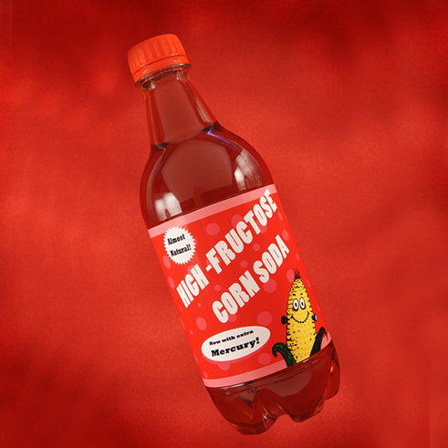
We eat it all the time without realizing we are, and without knowing how much it hurts us. It’s slowly killing Americans and people around the world.
The second way is drinks. Consider this for a minute. We have little stores on every corner full of liquid high fructose corn syrup.
It’s like a deadly drug and it’s available from vending machines in schools, your work, rest area stops, and hospitals.
It’s in the front of every grocery store.
It’s in the chocolate milk that school serve every day.
Mini marts: get your sugar fix here!

Who goes to mini marts? Well, we all do, but kids especially. They go buy candy bars, sugary drinks, and junk food.
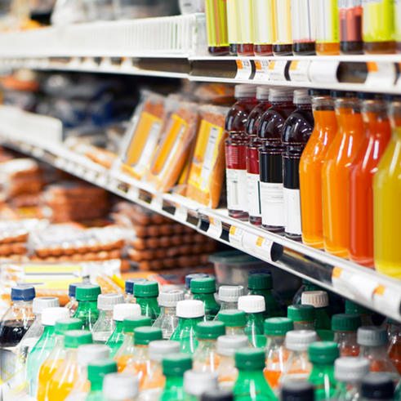
In the last few decades, we’ve increased our soft drink intake by 41% and fruit drink intake by 35%.
One can of soda is 150 calories. One can a day for a year equates to a weight gain of over 15 pounds.
And like other things, serving sizes have gotten bigger. Or rather, the amount we’re given in a product.
Coke and other drink bottles have gotten bigger. The typical 20 oz bottle 2.5 servings, but everyone drinks it as one.
The caffeine and salt in these drinks are diuretics so you’re still thirsty, but the sugar hides the saltiness.
Studies show that soft drinks raise the risk of Type 2 Diabetes.
Some children eat junk food and drink these sugar filled drinks without gaining a lot of weight.
They expend tons of energy. But watch these kids grow up. They have weight problems later on.

These drinks and treats leave many feeling tired within a few hours, needing another sugary drink.

So you skip the mini mart...what about coffee stands?
Some people might be thinking, “Hey, I don’t go to mini marts or drink soda, but I’m still struggling with my weight.”
You know that afternoon slump? Do you hit a coffee shop or stand and get a latte, mocha, or other yummy drink?
It’s just one a day. And it’s just coffee.
But it’s full of fructose from the syrups.
You get some energy, but you have a sugar spike and then crash.
And the energy burst from caffeine eventually doesn’t work as well. So really, you’re getting a sugar high that ends up making you feel worse.
And you fix that with another coffee.
This sugary cycle makes us tired, sick, and overweight.
You will probably admit that you end up feeling bad after sugary treats and drinks.
But now you understand that high fructose corn syrup tricks your brain. Your body thinks it’s not getting all that sugar and energy.

Your body is trying to survive and get energy, even while you’re sugar loading, so you’re hungry, tired, and eventually sick.
Here’s a tip. You could greatly improve your diet and health if you make your own coffee.
In the morning or for that afternoon slump, have a couple cups with a teaspoon of sugar and cream.
Even two teaspoons of sugar is less damaging than the higher amount of high fructose corn syrup in a mocha.
You can start with more sugar and slowly cut down, and you can actually lose weight this way.
That’s because sugar, while not healthy, is not as bad as corn syrup.
You can wean yourself off of adding sugar too. Once you get used to coffee with just cream, it tastes good.
You’ll eventually want to cut back on coffee in general, but this step will make a huge impact.
The same applies to diet food. It is actually healthier to eat a sugar cube than a sweet diet snack with corn syrup.
Or even better, go for fruit.
Dates are super sweet. They’re also full of fiber, and considered a super food by many.
I eat them instead of chocolate because they melt in your mouth almost the same way.
Our bodies can handle this type of sweet. We aren’t designed to handle high levels of fructose by itself, without fiber.

Diets
Many diets don’t work. If you’ve struggled with weight gain, you know that.
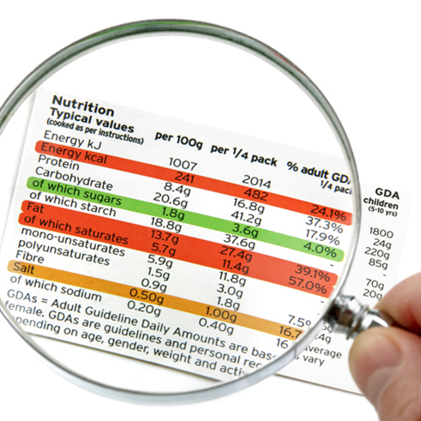
A few do work. People who do a 30 Day Sugar Challenge lose weight. They cut all added sugar.
It works if you check labels and make sure not to eat any kind of sugar, and that’s a real challenge with any packaged foods.
The Keto Diet and the Japanese Diet both cause people to lose weight.
The interesting things there is the difference between them. The Keto Diet is all fat and no carbs while the Japanese diet is all carbs and no fat.
They’re opposites, right? Actually, they both eliminate fructose. Aha.
So if you’ve tried Weight Watchers, you might have had some success.
But take a look at the ingredients in the products.
Many diet foods have high fructose corn syrup to replace fat. They might also have soy, which causes hormone issues that lead to weight gain.
Some people gain weight on Weight Watchers!
If you want to lose weight, cut added sugar! (In particular fructose)
Eat whole, natural fruit.
People who switch to Paleo lose weight, others who become Vegan lose weight…
…Whether you choose to become Paleo, Vegan, Bright Line, Keto or perhaps you won’t follow any ‘diet’, the key is that your lifestyle involves very little processed foods, and in particular, cut the added sugar, and eat more REAL organic food.
Here’s a simple plan that works.
1. Get rid of all sugary liquids. Only water and super low sugar drinks. (There is no such thing as a good sugar drink.)
2. Eat carbs with fiber. (Fiber is good for us and an essential part of our diet.)
3. Wait 20 minutes to eat second portions.
4. Buy screen time minute-for-minute with physical activity
Exercise improves skeletal muscle insulin sensitivity, reduces stress, and makes the TCA cycle run faster.
In essence, exercise helps people burn the calories before they become fat. That prevents all the problems mentioned here.

Your big takeaway
STEP 1: Cut added sugar from your diet (in particular fructose).
Check labels for corn syrup, corn syrup solids, high fructose corn syrup, and fructose.
These are poisons.
Remember to look at labels even if the product isn’t sweet. It’s in most breads, sauces, packaged foods, desserts, and anything creamy. It’s in diet food.
Cutting added sugar in general is very good for you.
This might sound like work, but imagine dropping 10, 20, 50, or 100 pounds and feeling amazing.
Imagine not feeling tired all of the time, and not fighting diseases and paying both physically and financially.
You can also fight diabetes, heart disease and more. And in some cases you can reverse these conditions.
Your health and well-being are worth it!
STEP 2: Watch “Food, Health & You” And Join The Movement…
Food, Health and You is a cutting-edge new documentary series that reveals a LOT more about your health than what is covered in this short report here.
You’ll discover how to use nutrition to fight and prevent obesity, diabetes, cancer, gut health problems, heart disease and more.
You’ll uncover the truth about what the food industry is hiding from you, and what the pharmaceutical companies don’t want you to know about processed food and medication.
Unfortunately Sugar isn’t the only culprit, though it’s certainly a big one. You’ll discover the truth about all the foods that are harming your life, and more importantly…
…You’ll discover SUPER-FOODS, and how to use them to lose weight, while fighting and preventing disease!
Follow this link:
Click Here To Watch The Food, Health & You Series
{Link the above text via your affiliate link}

